Project Proposal

Problem Definition

Description of the Complex Problem
The satellite remote sensing images of water bodies are a tricky computer vision issue because of high spatial variation, environmental noise, and spectral closeness of water and the adjacent terrain surfaces (Li et al., 2019). The pixel level classification happens to be especially difficult due to aspects like season change, cloud cover, atmospheric distortion, sensor noise and mixed pixels. Conventional image processing and threshold methods are highly dependent on handwritten rules that are usually not very robust and cannot be generalised to different geographical locations and image conditions (Huang et al., 2020).
Recent developments in deep learning-based semantic segmentation have shown good promise in solving these difficulties where the spatial and contextual features (Ma et al., 2021) are automatically learned based on image data. Nevertheless, the performance of segmentation across architectures is highly different based on the depth of the model and strategy of features extraction and complexity of computations (Zhang et al., 2020).

Importance of the Problem
Flood monitoring, water resources management, environmental conservation, and climate change require reliable water body extraction. Correct water mapping will aid in early warning (Pekel et al., 2019), hydrological modelling, and long-term environmental evaluation. Wrongful segregation can cause a poor estimation of the flood extent or make incorrect policy decisions especially in times of extreme weather (Donchyts et al., 2021). As the quality of satellite images available through satellites like Sentinel-2 increases, there is a growing push to develop automated, scalable and precise methods to be able to handle large amounts of data efficiently as well as to be able to maintain the same level of performance across different conditions.

Intended Audience and Beneficiaries
The results of this project apply to a broad scope of stakeholders, which include:
- Environmental researchers analysing surface water dynamics and ecosystem changes
- Government and other state agencies that deal with water resource planning and policy-making.
- The officials in charge of disaster management in regard to flood monitoring and emergency management.
- Geospatial developers of urban planners and infrastructure developers.
- Remote sensing practitioners and data scientists who want to find an evidence-based way on model choice.
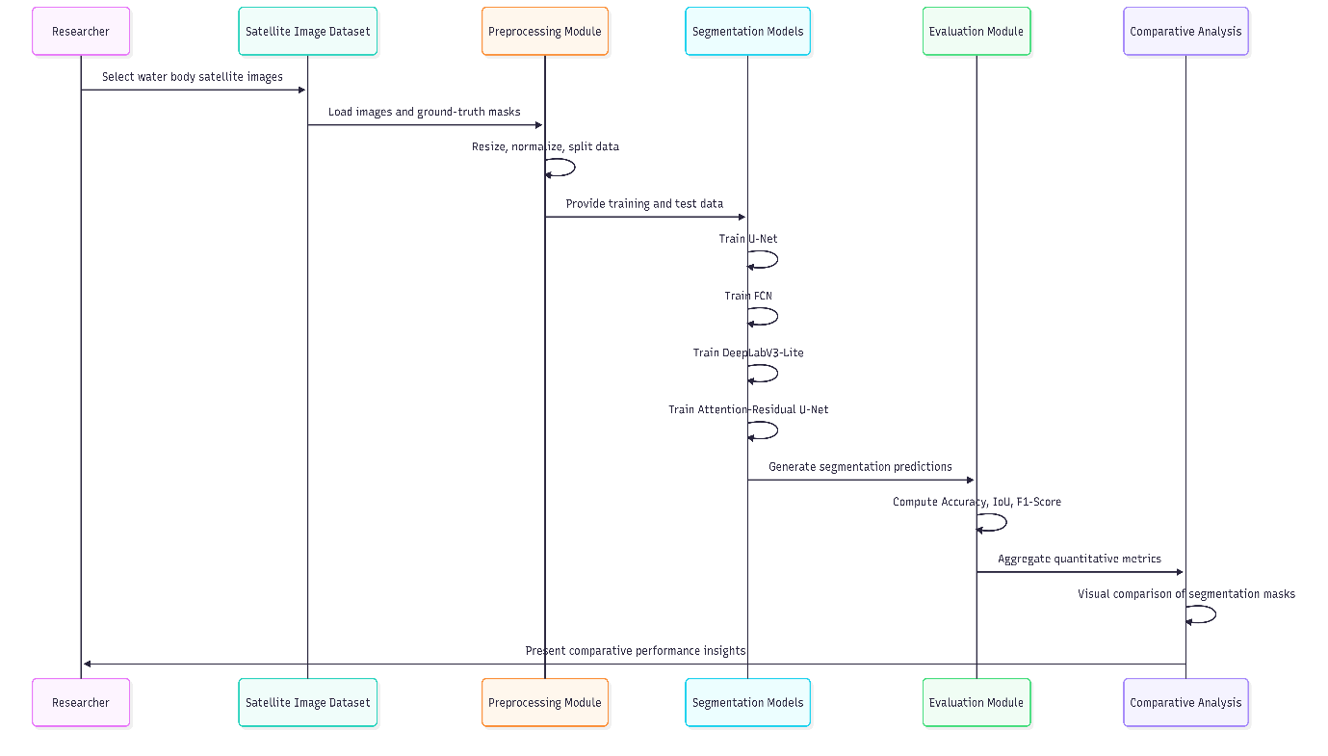
Figure 1 : Workflow diagram illustrating the comparative evaluation of segmentation models

Research Gap and Motivation
Despite the application of some of the most popular deep learning architectures to semantic segmentation, including U-Net, Fully Convolutional Networks (FCN), DeepLabs-based models, attention-enhanced networks, and others (Chen et al., 2018), individual model or inconsistent datasets and evaluation strategies are frequently used in existing studies (Minaee et al., 2021). Such absence of comparability impedes the process of identifying the most appropriate architectures to water body segmentation with similar experimental settings. To fill this gap in research, it is necessary to conduct a systematic comparative analysis with homogeneous datasets, homogeneous preprocessing pipelines, and homogeneous performance measures.

Selling Point for the Project Pitch
The main strength of the project is that it will comparatively analyse several deep learning semantic segmentation models to map water bodies on satellite data. Through a rigorous and comparative study of four architectures, on the same experimental setup, the researcher gives clear evidence-based information on the performance, robustness, and weaknesses of the models. This comparative view provides practical utility to more than a one-model solution, which is to provide informed model selection in real world environmental and remote sensing applications.

Technical Approach

Proposed AI Techniques
The project utilises the Computer Vision methods based on Deep Learning, and mainly, semantic segmentation to classify satellite remote sensing images at the pixel level. As a fundamental computer vision problem, semantic segmentation allows the accurate localisation of water and non-water areas by assigning each pixel a class label (Minaee et al., 2021) in accordance with the current application. Convolutional neural networks (CNNs) have been applied to analyse highly geospatial images by learning hierarchical spatial features automatically, which is best applied to image data (Chen et al., 2018).
Figure 2 : Flow chart illustrating the proposed deep learning–based computer vision approach for pixel-level water body segmentation.

Selected Deep Learning Models
Four semantic segmentation architectures are used to support comparative evaluation, including U-Net, Fully Convolutional Network (FCN), DeepLabV3-Lite, and Attention-Residual U-Net. These architectures are a variety of architectural approaches, such as the encoder-decoder architecture, which can be atrous convolution to extract the multi-scale context (Zhang et al., 2020), and attention mechanisms to improve the learning of features. A variety of architectures allows a systematic study of the accuracy of segmentation, the stability of segmentation and the efficiency of the architecture.

Initial Methodology
The first methodology involves a well-organised and replicable experimental design. The binary water masks and the corresponding satellite images are initially pre-processed in terms of resizing, normalisation and standardisation of format. The data is then divided into the training, validation and testing subsets to make sure that the performance is evaluated without any bias. All models are trained offline through similar preprocessing actions and similar training settings. After the training, every model is tested with the help of unified inference pipeline on unseen satellite images, which is fair when comparing them.
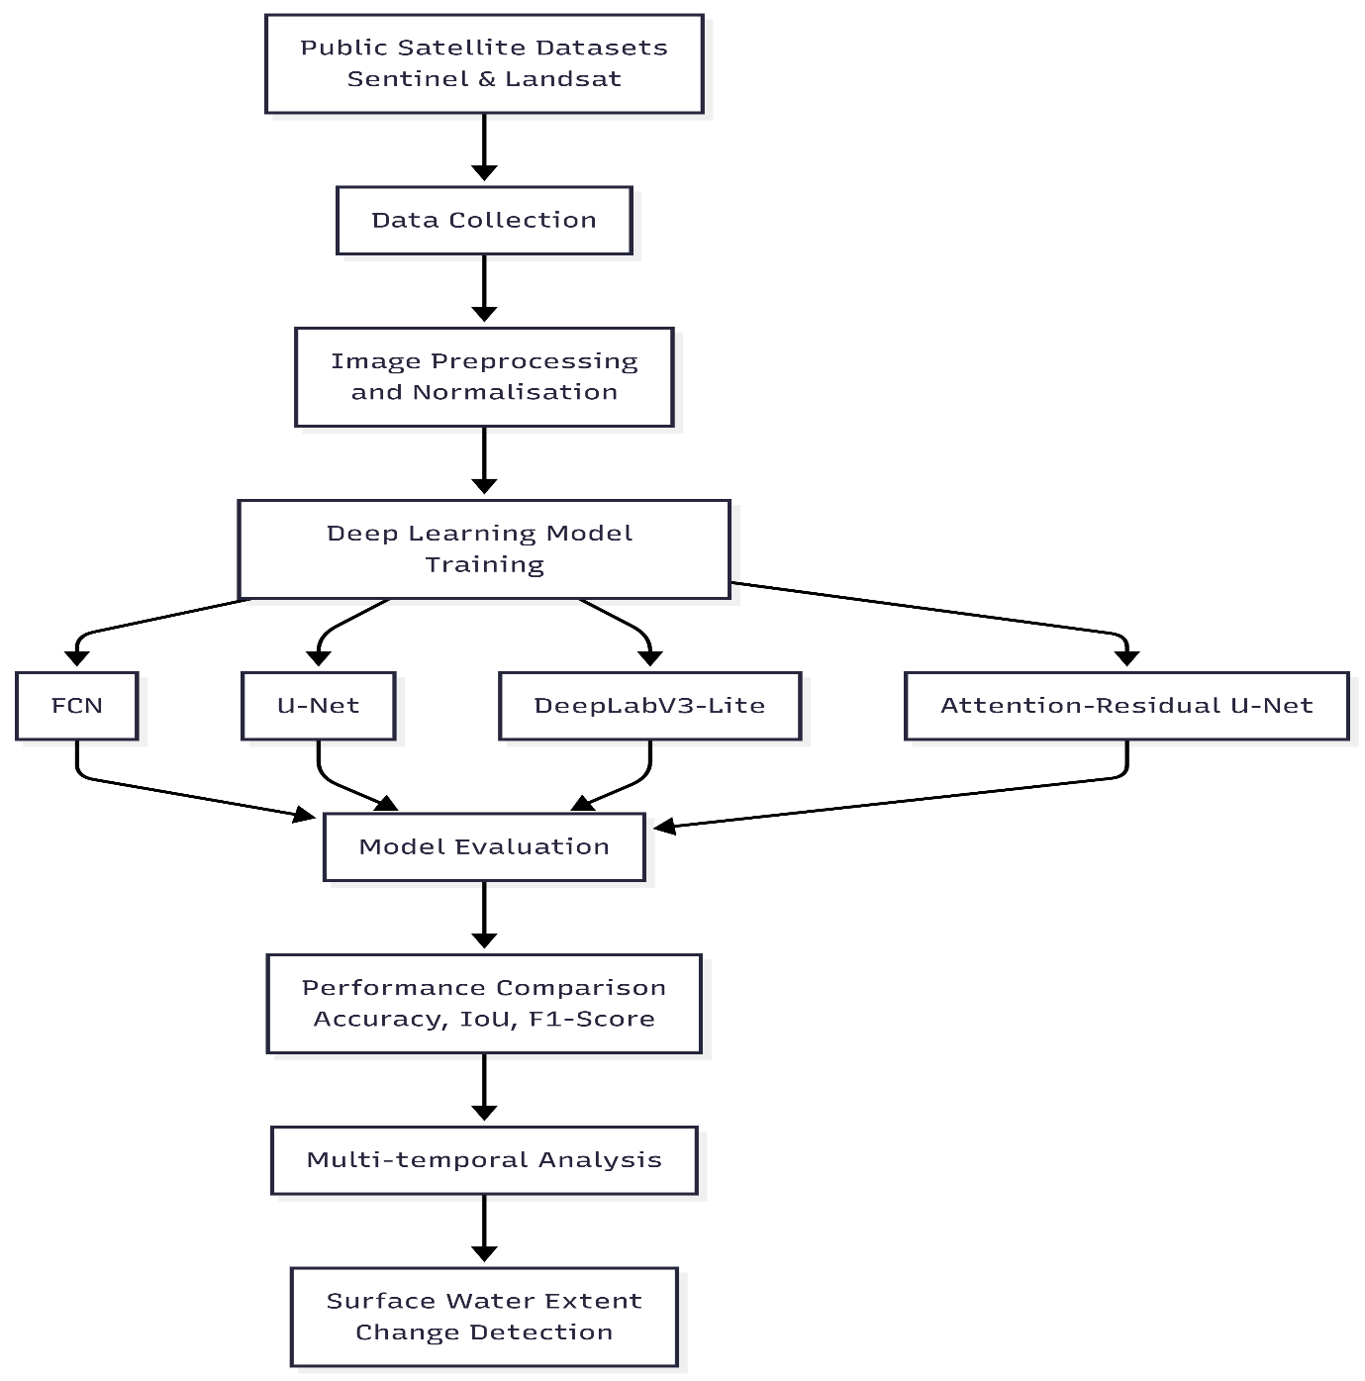
Figure 3 : Flowchart illustrating the objectives and workflow of the proposed deep learning–based water body segmentation study.

Data Pipeline and System Architecture
The system structure is modular and is composed of the data ingestion, preprocessing, model inference and output visualisation phases (Ma et al., 2021).). When inferring, trained models produce pixel-wise segmentation masks and these are post-processed and superimposed on the original satellite images to aid in the qualitative analysis. This pipeline can be used to guarantee reproducibility, and model results can be directly compared under the same conditions.
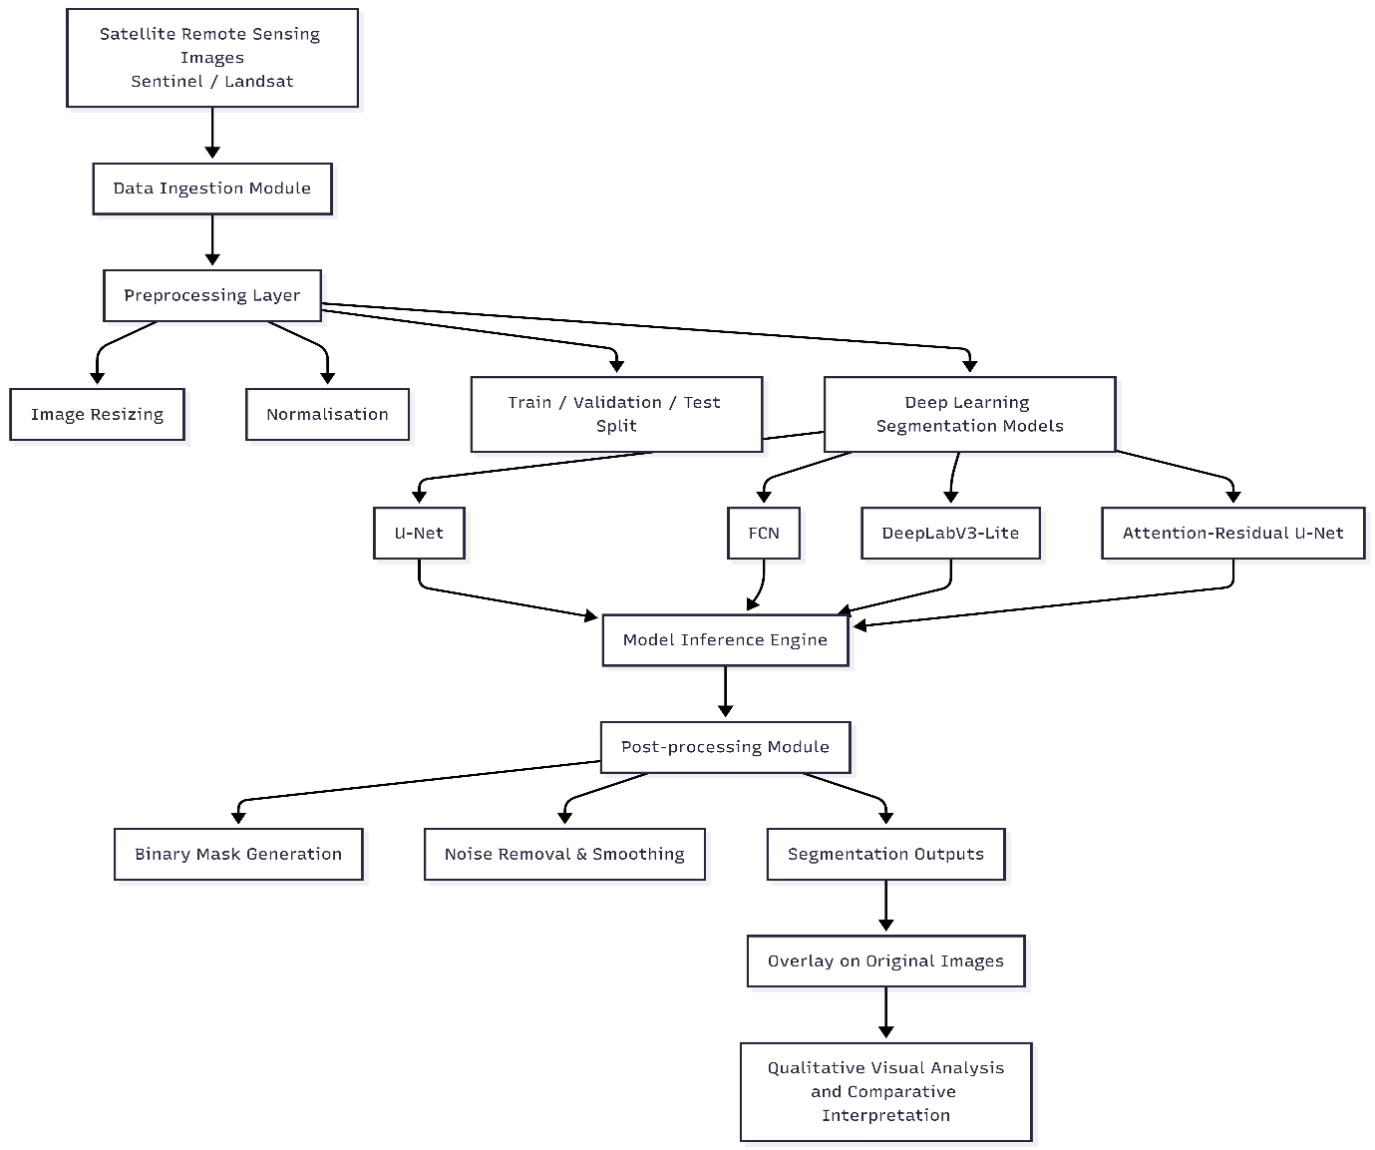
Figure 4 : System architecture illustrating the data pipeline, segmentation models, inference, and visual analysis stages for water body extraction from satellite imagery.

Learning Outcomes and Intelligent System Design
The project allows investigation of the contemporary intelligent systems through the application of high-tech deep learning architectures to a real-world computer vision problem. It shows how AI solutions based on data are designed, including data preparation, developing the model, evaluating the model, and interpreting the model. The project forms an important development of the critical skill in system design, model appraisal, and evidence-based decision-making, which directly reflects the learning results associated with highly developed AI methodologies and application of intelligent systems.

